

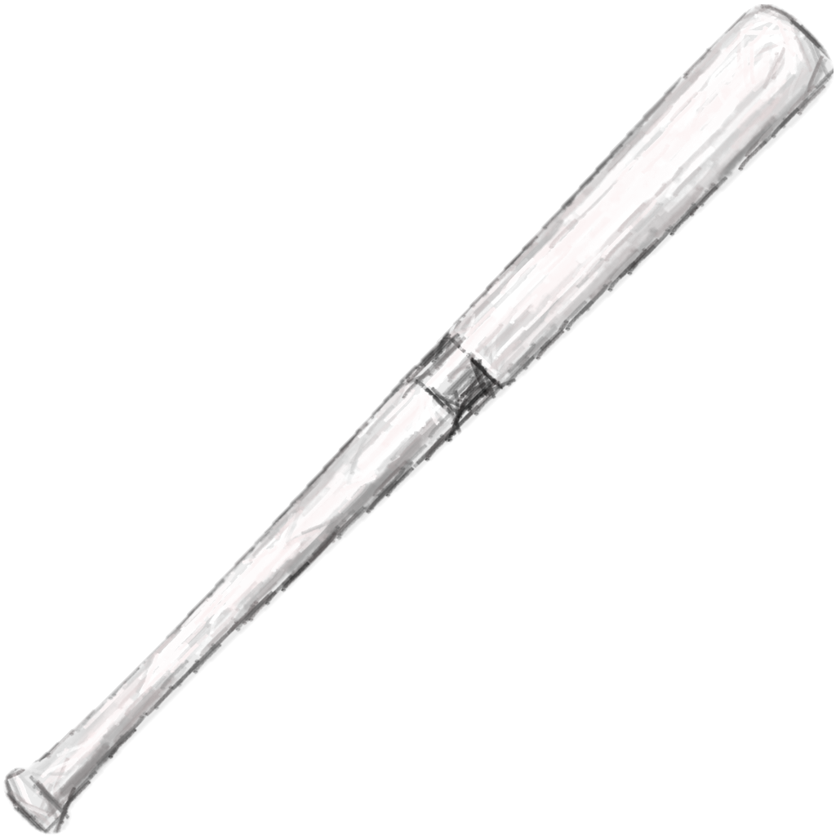

**2018 Pre-Season Baseball Tournament**

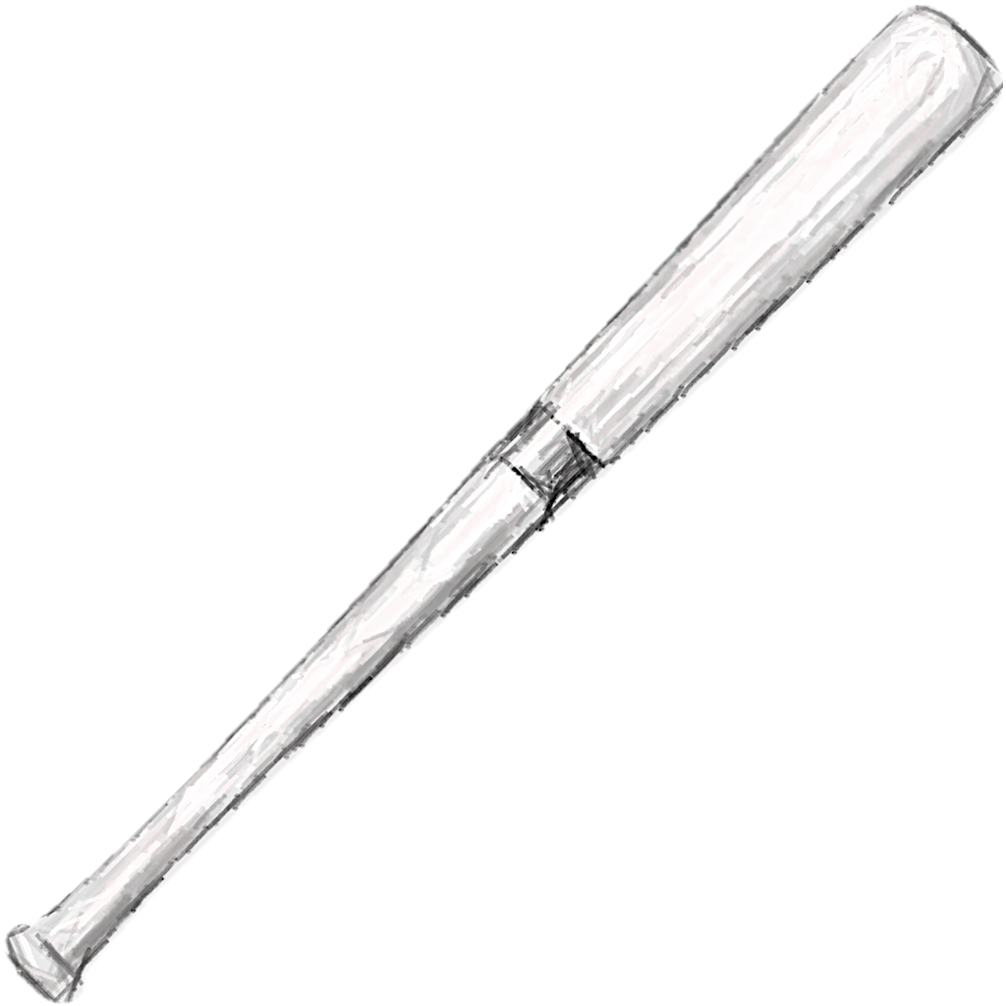



**AGE GROUPS:**

**6U**

**8U**

**10U**

**12U**

**15U**

**APRIL 13th & 14TH**



For more information or to register contact:

**Trey Lewis**

PHONE**:** (501) 514-8284

EMAIL**:** tlew2433@icloud.com

**Johnny Alexander**

PHONE**:** (501) 428-4701

EMAIL**:** johnny.alexander@cityofvilonia.net

WEBSITE*:*

***https://leagues.bluesombrero.com/Default.aspx?tabid=945593***

**VILONIA BASEBALL PARK: 26 Cemetery Drive, Vilonia AR**

DOUBLE ELIMINATION TOURNAMENT

**$150.00 Entry Fee**

*\*\*DEADLINE TO ENTER IS APRIL 10TH*